Nicolas Viader

**Smart Contracts Against Labor Mismatches**

**HT Blockchain Competition**

**HOW TO APPLY SMART CONTRACTS IN THE**

**LABOR SYSTEM**

Labor mismatches are an issue which we all have learned to deal with in our first jobs, and in some cases, it is still being a problem. When we are young and we are looking for our first jobs, we only think about earning money, and sometimes we don’t know or we ignore the injustices or inequalities from our job contracts, such as the non-payment of extra hours or the obligation to do an unassigned task. With the implementation of Blockchain and Smart Contracts in labor world, we can fix those irregularities by creating an algorithm which establishes a series of conditions signed before by both parts, the boss and the employee, and have a more control of every job conditions, attendances, and salaries.

First of all, to talk more about how to fight against labor injustices through Smart Contracts, we should define what is a Smart Contract and its relation with Blockchain. Smart contracts are just lines of codes stored on a Blockchain that are executed when predetermined conditions and terms are fulfilled. In our case, the program will display the payments, if the employee meets successfully the conditions stablished before in the Smart Contract. Those conditions and the fulfillment of these, will be supervised by other users by the Blockchain system, and all the transactions will be stored in blocks and will have twelve copies in different user’s blockchains to avoid manipulations. If these conditions become true, the algorithm will lead to the next step until the final step, which will make the payment in cryptocurrencies automatically. We are talking about to implement a new labor system which will change the payment methods and will simplify them to a unique method for all workers. The implementation time for this new method may vary depending on two factors: the Government, who has to accept this new system and create an organization in charge of it; and the companies, which will have to know about this innovative idea and implement the necessary changes to his company. If both parts work hard to implement this new system, it can easily be functional by 2021, and be implemented worldwide in around three-four years, when big companies sees that this new payment system is beneficial for them and for their employees, and countries with a technologically advanced society that wants to take the step towards this new future of the world of work.

**ALGORITGHM OF THE SMART CONTRACT**

These Smart Contracts will have an algorithm consisting of different parts, creating a series of conditions, where if all they are true, the employee will get his corresponding salary. The four parts of the algorithm will be:

* + 1. The first part of the algorithm will be formed by both parts of the contract, boss and employee, where they will rule the job conditions that the employee will have to accomplish in a certain period of time to get his salary. This can be for example the number of hours that the employee must work per-week, or the objectives to accomplish, always ruled by the Government and the Labor Rights. If both parts of the contract agree the agreed contract, they will sign it and the contract will be stored in a Blockchain and the algorithm will lead to step two:
  + 2. Once the contract is stored on a Blockchain, the government will check and rule the conditions of the job contract depending on the laws, the Labor Rights and the worker. Not all the jobs require the same amount of time, the same conditions or the same salary. The organization in charge to confirm and validate those contracts will have access to lead to step three or not. The Blockchain users will have to validate this validation and this will be stored also in a Blockchain.
  + 3. Once the contract is validated, every job will have an obligatory attendance system, in which all workers will have to confirm an attendance every time they go and come, to control how many hours each employee does per-week to calculate the salary. Each company will decide if they implement a swipe up card attendance system, an app in which all the workers will need to use every time they come and go to work, or just geolocation with the phones or special devices for it. This information will be stored in a decentralized network, as Blockchain does, so this information cannot be modified and will be transparent for all the users. If the worker meets the assigned hours and objectives, the algorithm will lead to step four. If not, it will calculate his correspondent salary based on the hours and the contract conditions. And then led to step four:
  + 4. The banks. Once the algorithm is on step four, this will mean that the worker completed his duties, and the banks will receive the confirmation to display this payment. They will subtract your correspondent salary from the company’s blockchain you work for, and it will be added to your blockchain, making a copy of this transaction in twelve different users. Neither managers or bosses or the government will have to pay you: it will be the bank who directly does the correspondent transaction in cryptocurrencies depending on the result of the algorithm and conditions of the Smart Contract.

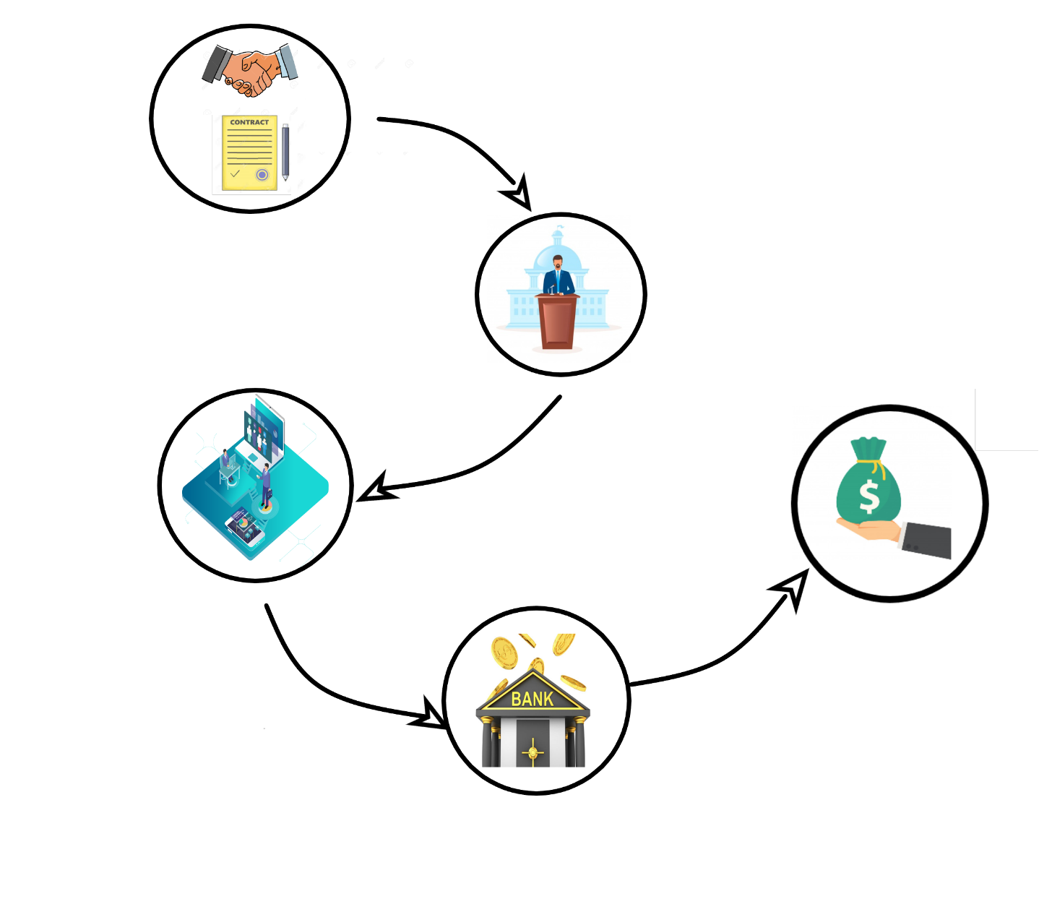

*Graphic of the Smart Contract algorithm*

**CONCLUSION**

With the implementation of these Smart Contracts and this algorithm in our society, it cannot only change the labor market, it can change the economy of the country. A country where the working conditions and the process of payment will be the same for every worker, doesn’t matter if it’s a bigger company or smaller, and all the transactions and payments can be visible and not modified, will have an increase of its economy due to it can create a more regulated labor system to avoid corporate corruptions and an increase in working productivity. Having all data stored in blocks, it will be also useful for the algorithm to calculate your future pensions depending on your earnings and the fulfillment of your contracts. If you miss more of a percentage stablished by the government, without a justified fault, you will not have access to your pension. This will increase the productivity of workers and the commitment of these. However, if you completed your assigned hours, the algorithm would calculate your salary, depending on hours, earnings, and commitment, accorded in the first step of these Smart Contracts. The implementation of this new system would not be a great cost for the governments: they will only have to create an organization in charge of checking the part two of the algorithm. The cost will be for the companies, but it won’t be a great cost because they would only have to implement an obligatory attendance system for each company, and it can be online implemented by an app or a program, so it’s not necessary a cost. With this new payment system, we won’t have to worry about if we could make ends meet. You will have a weekly payment of your correspondent hours of work, and this payment will be always at the same schedules on Sundays, depending on the business sector in which you work, but always on Sundays.

All this information of our salary, our earnings and all the transactions stored in blocks will be unassailable. Nobody can modify this information because it will be visible and every block will have twelve copies in different user’s blockchains, so if a hacker tries to modify this information from a block, there will be another eleven blocks with the same information, where if one doesn’t match the others, an alert will appear. This system will convert the money into information, information that cannot be stolen or manipulated. We all will have our blockchain where our earnings will be visible and protected, creating for every transaction a new block, and making a copy of every new block in twelve different blockchains every time, creating an impregnable cryptocurrency storage system, and a new contract system.

This will provide to the government a more controlled and regulated economy, and for the people an equal and transparent society. Say goodbye to labor mismatches and robberies with this new system of Smart Contracts and say hello to a regulated and fair labor market. This untapped technology will provide total transparency, fighting corruption and returning power to the people, taking that power away from the banks, and giving the users the control of all the process that the algorithm does.

All innovative ideas like internet, the train, or mobile phones seemed like crazy ideas

until they came true and changed the world. The world is changing and evolving into a digital

age, and you, do you want to be part of this change?